**Sounds of Piano**

This work is a piano duet using interior piano techniques. I have experimented a lot with the piano such as hitting the bars or frame with different kinds of mallets, executing glissandos on the strings with the fingertips and fingernails anywhere inside the piano. Also, I discovered some sounds from the keyboard, lid, and tuning pins. The main purpose of this composition is to use the materials that I found from experiments, and it is mainly focused on composing with timbres.

One of the sounds is a reference to *Guero* by Lachenmann, which is the glissando on the keys’ edges without depressing the keys. However, the notation is slightly different in *Sounds of Piano*. The examples below show the notational difference between *Guero* and *Sounds of Piano* for this technique.

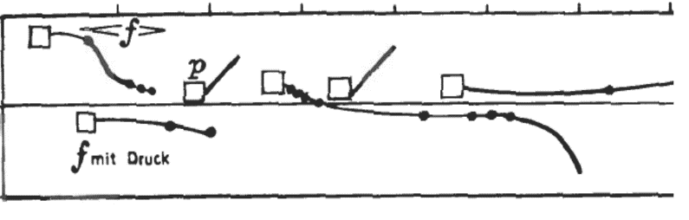

Figure 1: Guero’s notation

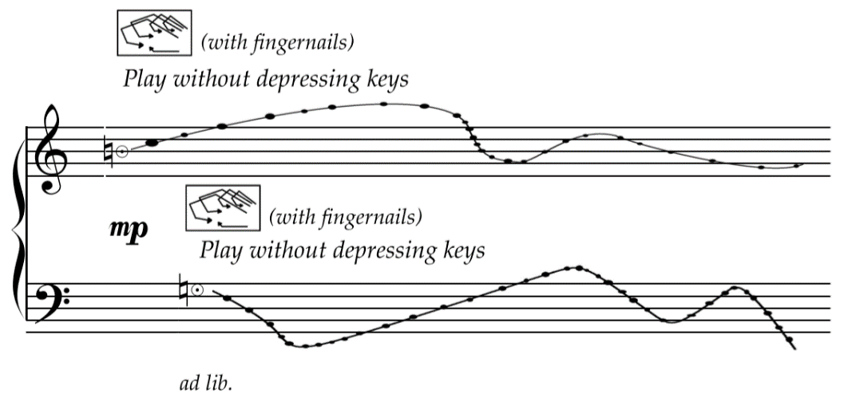

Figure 2: Sounds of Piano’s notation

Besides this, I discovered a whale-like sound created by ERSR mallets (rubber balls that create a unique effect by rubbing) rubbing the frame and bars with the sustaining pedal down. This was influenced by George Crumb’s *Vox Balaenae*. Crumb was inspired to write *Vox Balaenae* after hearing a recording of whalesong; he used flute, cello and piano to imitate the sound. However, with ERSR mallets, it creates a deeper and thicker sound. Also, rubbing in different speeds and sizes of ERSR mallets can change the pitch and the timbre. This work has explored the various ways to use ERSR mallets, such as different speeds of rubbing in page 9 and pressing the mallet down to bounce rapidly in page 6.

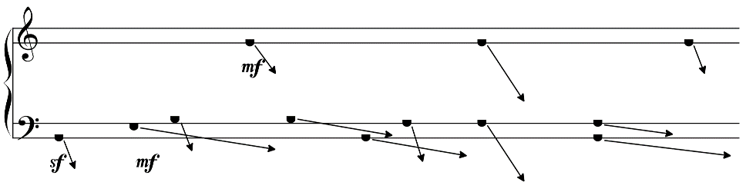

Figure 3: various speed of rubbing on bars in page 9

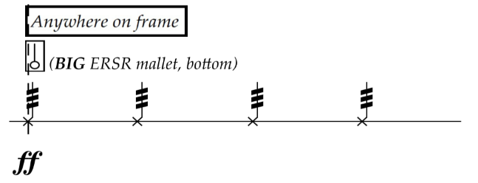

Figure 4: press the mallet down to bounce rapidly in page 6

The work is in sonata form. The exposition begins with a floaty section ending at 0:50" on page 3, followed by a drier section to create contrast. The development starts with the material from the beginning at 2:10" on page 7. New material is introduced and developed in 2:20". The development ends at 4:10" on page 13. The recapitulation begins with the material from the opening but rapidly swaps to the material from the dry section in the exposition, but the sustaining pedal is kept down this time. The work concludes with a a coda reminiscent of the first section which revisits opening material.

Additionally, a performance instruction is provided for the work, to clarify what tools are required and where exactly on the instrument is required to be played. Alongside this, some suggestions for performing the work, such as handshapes, are included in the instruction. I experimented with some suitable handshapes for unusual techniques, for example “*Damp strings with lower palms and twist palm*” is suggested for a handshape that is against the traditional shape.

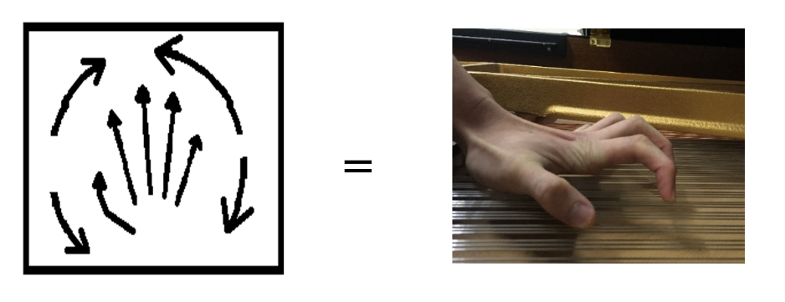

Figure 5: suggested handshape for “Damp strings with lower palms and twist palm”

In addition, performers are required to follow the stopwatch while performing the work; the timing is stated in the beginning of every system, which is 10 seconds for each system.